Facts About The Bible
David A. Padfield / Reflections On Truth
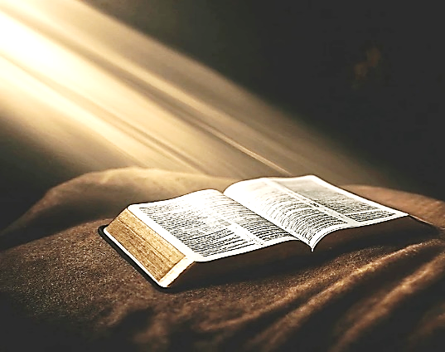
The Bible is composed of 66 books. There are 39 books in the Old Testament and 27 in the New Testament. Some 39 or 40 men had a part in the writing of the Bible, from Moses to the apostle John. It took over 1500 years to produce the Bible.
Out of all the men who wrote the books of the Bible, Luke (the beloved physician, Colossian 4:14), was the only Gentile. He penned the gospel of Luke and book of Acts.
The first section of the Old Testament is called, The Pentateuch. It contains the first five books of the Bible (Genesis, Exodus, Leviticus, Numbers and Deuteronomy). These books, written by Moses, cover the period of time from Creation to the death of Moses, just prior to the entrance of God’s people into the promised land.
The Old Testament contains twelve books of history, from Joshua through Esther. There are five books of poetry (Job, Psalms, Proverbs, Ecclesiastes and the Song of Soloman). There are five books of major prophets (Isaiah, Jeremiah, Lamentations, Ezekiel and Daniel). There are the 12 minor prophets, from Hosea through Malachi.
The New Testament contains four gospels (Matthew, Mark, Luke and John), each telling the story of the life of Christ from different viewpoints. The New Testament has only one book of history, the book of Acts, which tells of the establishment of the church and the growth of Christianity in the first century. It also has 21 epistles (letters), the majority of which were written by the apostle Paul (Roman though Jude [Hebrews is at question]), and one book of prophecy (the Revelation), penned by John while on Patmos.
The Old Testament was written in Hebrew (with the exception of Daniel 2:4b-7:28 and Ezra 4:8-6:18). The New Testament was written in Greek.
The Catholic Bible (including the Douay version, the Confraternity version and the New American Bible) contain seven extra books: Tobias, Judith, Wisdom, Ecclesiasticus, Baruch, First and Second Maccabees, plus additional parts in the books of Esther and Daniel. Neither Jesus, nor the apostles ever quoted from these books as if they were inspired. The Apocryphal books were rejected by the first century Jewish Flavius Josephus and were never accepted by the Palestinian Jews. When Jerome (now a Roman Catholic “saint”) translated the Hebrew Old Testament in Latin, he rejected these books as non-canonical (383-406 AD). The Apocryphal books were not even received by the Roman Catholic Church until the Council of Trent on April 8, 1546.

