So Is Everyone Who Is Born Of The Spirit
Kenneth D. Sils

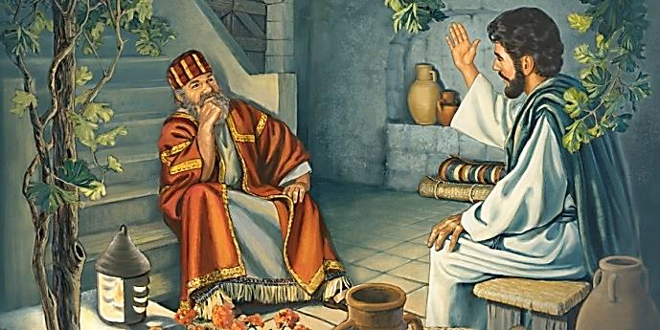

“Jesus answered and said to him, ‘Most assuredly, I say to you, unless one is born again, he cannot see the kingdom of God.’ Nicodemus said to Him, ‘How can a man be born when he is old? Can he enter a second time into his mother’s womb and be born?’ Jesus answered, ‘Most assuredly, I say to you, unless one is born of water and the Spirit, he cannot enter the kingdom of God. That which is born of the flesh is flesh, and that which is born of the Spirit is spirit. Do not marvel that I said to you, ‘You must be born again.’ The wind blows where it wishes, and you hear the sound of it, but cannot tell where it comes from and where it goes. So is everyone who is born of the Spirit.’” (John 3:3-8)

This is an amazing text of Scripture that readily sets off the radical changes that were coming to the Jewish people and the entire world. The Jewish Messiah has arrived and offers all people an opportunity to see and then, enter His heavenly kingdom! Nicodemus, a ruler among the Jewish people, knew Jesus was on God’s side for the miraculous signs coming from Jesus confirmed it. Yet, I don’t believe Nicodemus was prepared for what he was about to hear.
And what was Nicodemus hearing? “Ye must be born again!” That message simply did not compute! There was no such concept found among Judaism. You were simply “born” into the Jewish system. Little boys were circumcised on the 8th day of life and then, Jewish children were taught about their ancestors and the grand covenant they alone had with the great I AM! Nicodemus was simply blindsided by Jesus’ insistence of being born again. (continued on the back)

