Every Knee Shall Bow
Kent Heaton – Poudre Valley e-bulletin
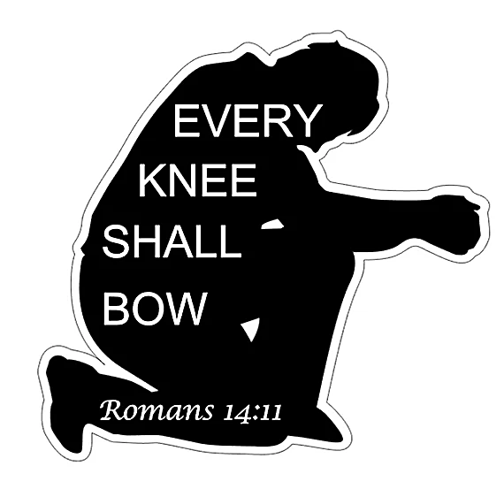
The certainty of death is evident by the myriad of marble gardens dedicated to the memories of loved ones. Death is the unwelcomed guest in every home without exception. It matters not if one is rich or poor, young or old; death embraces all. The Bible affirms this truth and adds one more element of certainty. “And as it is appointed for men to die once, but after this the judgment” (Hebrews 9:27). As certain as the day of death so shall all men stand before the certainty of judgment. It to this judgment that we find a message from God: “'As I live', says the Lord, 'Every knee shall bow to Me, and every tongue shall confess to God'” (Romans 14:11).
Pride is the fuel of man’s arrogance as he thinks of himself more highly than he should. Mankind has been able to send instruments to far reaches of the solar system and to plumb the deep parts of the oceans. Through technology he has been able to bridge information at incredible speeds and build a vast network of unparalleled knowledge. Nations have risen over the centuries with might to crush other nations and today men stand upon pedestals of perceived power believing they are without equal in a world dominated by the exaltation of man. Industries of wealth are led by those who have the ability to change the course of a financial market with the swipe of a pen. Greatness is the mantra of our day. But there is a day coming that will change all this.
In the song of victory over the Egyptians, Moses and the people proclaimed, “Who is like You, O Lord, among the gods? Who is like You, glorious in holiness, fearful in praises, doing wonders” (Exodus 15:11)? How can man compare the greatest thing he has ever done with the power and might of Jehovah God? In all the centuries of man when has he ever found an answer for the first of the realities of life: death? The answer is that no matter how man tries to convince himself that he can live forever he will always die. Why is that true? Because God has established the law that will never change (Genesis 3:22-24).
If the first reality is true (death) then the second reality is true: “Every knee shall bow” before the Lord. The most powerful man or woman in the world will bow the knee before God. Riches will not change that; arrogance will not change that; military might will not change that - nothing will change the fact that every person who has ever lived along with every person now living and yet to live will bow the knee before the Lord. The irony of death is that it equalizes all men to the same level. When the Day of Judgment comes before the great throne of the Almighty there will only be one level field. Both knees will bow before the Creator and Savior of the world.
C. C. Colton wrote, “Of all the marvelous works of the Deity perhaps there is nothing that the angels behold with such supreme astonishment as a proud man” (Lacon, 1820). The angels know that all men will bow before God. We should learn from the word of God our true place in this life and the life to come. Our daily task is to prepare our knees for the day of judgment. The more we bow the knee here on earth the more blessed it will be when we bow the knee before the great I AM. All men will bow but only the knees of the saints will see Heaven. All men will bow but most will bow before the Lord hearing those terrible words, “Depart from me” (Matthew 7:13-14, 21-23). Take a good look at your knees. If you don’t bow now, you will one day!

