Eli: A Weak Leader
David Hartsell / Auburn Beacon

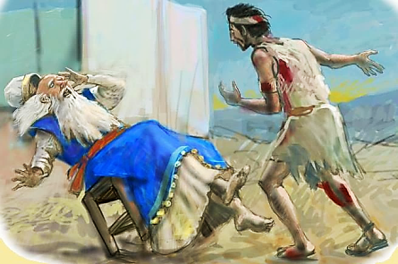

Eli was the next to the last Israelite judge. He was not only a judge but he was also the high priest. As political and religious leader, Eli was in prime position to influence many to follow God. However, though Eli was personally good, he failed as a leader: first as a father and then as a judge.
Eli had two sons, Hophni and Phinehas, who were priests. They were not dedicated to God but were extremely evil. They violated the sacrificial laws and were immoral with the women who assembled at the tabernacle. Their sins were so blatant that they caused many in Israel to abhor “the offering of the Lord” (1 Samuel 2:12-22). Eli reprimanded his sons for their evil behavior. “So he said to them, ‘Why do you do such things? For I hear of your evil dealings from all the people’” (1 Samuel 2:23). They ignored their father’s warnings and continued in their sinful ways. The text says that this was, “because the Lord desired to kill them” (1 Samuel 2:25). Clearly, God’s nature does not want to kill anyone or does not wish anybody to be lost. The meaning here is that they had such an irreverent, defiant manner toward all godly things that The Lord was determined to punish them.
The greatest lesson is that Eli failed in raising his sons. Training children involves modeling proper behavior before them. But that’s not all! We must teach them God’s will and discipline them too. Eli refused to restrain his sons from their wickedness (1 Samuel 3:13). He did not have the moral courage to do what he knew was right. Fathers are given the enormous task of raising their children in “the training and admonition of The Lord” (Ephesians 6:4). Eli did not do this, but we can.
Israel needed a strong leader during Eli’s time. The Philistines were threatening and Israel greatly needed God’s help. Yet, The Lord does not bless a people whose leaders show disdain for righteousness. You might say, “Eli was good. He followed The Lord!” It is true that Eli did not participate in any of the iniquities of his sons. Yet, he did not truly follow The Lord. In fact, God sent a prophet to tell Eli that his family was going to be punished because he honored his sons more than God (1 Samuel 2:29). Hophni and Phinehas were killed in battle with the Philistines. The Philistines captured the ark of God. Upon hearing of its capture, Eli, fell backward out of his seat and died (1 Samuel 4:18)!
Too often as fathers, we console ourselves by saying we don’t approve of what our children do. We are washing our hands of their evil deeds. Yet, we might not do the difficult work of standing against their sins. When we refuse to stand against evil, we fail as a parent and as a leader of God’s people.

