Did The Church Give Us The Bible?
James E. Cooper – Westview Bulletin

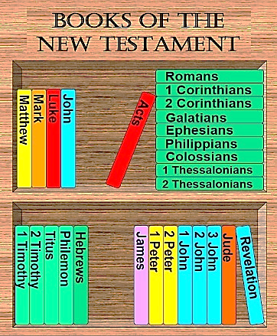

Roman Catholics have often repeated the claim that the Catholic Church gave us the Bible, and that this means the voice of the Church is more authoritative than the Bible. This kind of reasoning is behind many of the non-scriptural and anti-scriptural doctrines and practices of Romanism. To them, the New Testament is authoritative only when the traditions of the Church or the pronouncements of the Pope do not contradict it.
However, the truth of the matter is that the Bible did not originate with the church. It is true that the church existed before the books of the New Testament were written, but that does not prove the church to be the ultimate source of these books. Those who penned these books were all members of the Lord’s church, but “the church” did not produce the Bible.
Moses existed before there was a Law of Moses, and was one of the children of Israel, but this does not mean that Israel produced the Law. The Law originated in the mind of Almighty God, who delivered it to Moses who delivered it to the children of Israel. Only those who would completely discount the activity of God and look on this from a purely humanistic standpoint would dare think that “Israel gave us the Law.”
God speaks to mankind today by Jesus Christ (Hebrews 1:1). He called and prepared men to send out preaching His word. Shortly before His death, He promised to send the Holy Spirit upon them to enable them to remember what He had taught and to guide them into all the truth (cf. John 14:16, 26; 16:13). To hear these men would be to hear Christ (cf. Matthew 10:40; John 13:20). In that classic passage where we find Jesus promising to build His church (Matthew 16:18), we find Him promising Peter the keys of the kingdom of heaven and stating that “whatever you bind on earth shall have been bound in heaven, vs. 19”. The same language is addressed to all the apostles in Matthew 18:18. The tense of the verb is future perfect, which conveys the idea that when the apostles bound something, it had already been bound in heaven.
Apostolic teaching originated with God, not the church! For a while the Divine Message was being delivered both orally and in written form, but the message originated with God. The church of the New Testament resulted from this Divine Word.

