Dead Flies
Matthew Bassford – FB post
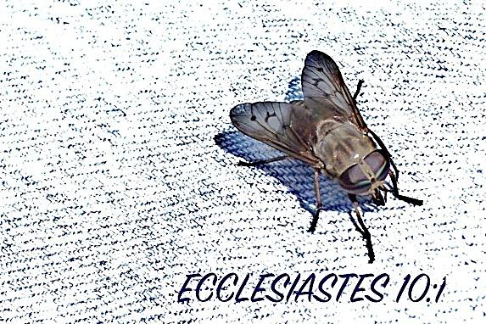

Ecclesiastes was my father's favorite book of the of the Old Testament, and his favorite verse in Ecclesiastes was 10:1. At least, I think it was his favorite verse. It certainly was the one that he quoted most to my teenage self. To this day, I have no trouble summoning up, “Dead flies make a perfumer's oil stink, so a little foolishness is weightier than wisdom and honor,” from memory.
Now that I have a ten-year-old son, I also have no trouble understanding why he wanted to imprint that one on my brain. He worried that with my great cleverness and scant sense, I would get into some kind of mess that would blight the rest of my life.
Sadly, it isn't only teenage boys who are given to dead-fly moments. According to Genesis 9:21-22, you can be 600 years old and still be foolish. There, we see Noah, patriarch, preacher of righteousness, and Hebrews 11 hero of faith, planting a vineyard, getting drunk and exposing himself. Thousands of years later, the descendants of Noah do the same kind of dumb stuff when they get drunk.
Sometimes, we manage disastrous foolishness when we are stone-cold sober. David did upon seeing one woman bathing on the top of her roof. Samson spoiled his perfume because of several different women. Judas blew it over 30 pieces of silver.
Nor should we today think that we are immune simply because we're churchgoing Christians who don't have the Holy Spirit chronicling our every misdeed. The devil loves to sow all of our paths with consequential temptations, and he loves even more to fool us into thinking that the sin won't be consequential if we commit it. David didn't think he was signing up for anything more than a one-night stand. Judas thought he could make everything better by giving the money back to the chief priests and telling them that Jesus was innocent.
Neither was correct. Today, the two facts that Christians are most likely to repeat about David are that he was a man after God's own heart and that he committed a great sin with Bathsheba. In the case of Judas, we don't even think about him proclaiming the gospel, casting out demons, working miracles, and doing all the other things that apostles did. We only remember his impulsive treachery.
So too, our dead-fly moments often are what stick in people's minds about us. What of the devoted husband and father who cheats that one time and gets caught? What of the gifted preacher who couldn't get along with the elders? What of the woman of God who couldn't control her temper with her sister or her sister in Christ? Decades later, the isolated foolishness is remembered more than the wisdom and honor.
When a little foolishness can be so powerful, the only solution for us is to avoid all foolishness. Any of us can spoil the testimony of a godly life with only one ill-chosen act. When we are tempted, then, we must remember the stakes. The devil would love to number us with Noah and all the rest. However, if we stick to the paths of wisdom, he will never get the chance.

