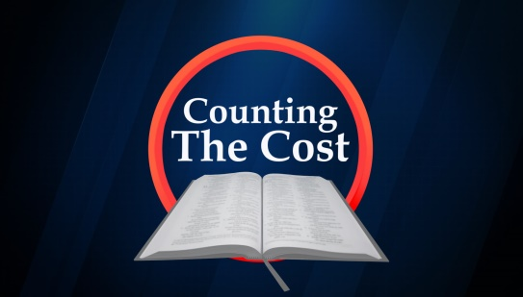

Anything that is of value will cost something. It will be money or time or some sort of effort on our part. An education will take time and money and lots of effort. A marriage will be successful with the same ingredients along with love, devotion and understanding. Operating a successful business requires the same ingredients. Most people understand this and willingly apply these things to whatever they choose to do. But we want to consider what salvation and Christianity will cost us in simple terms, and we will encourage you to make the right choice.
Becoming a Christian may cost us something in our human relationships. Jesus must come first and be more important than even our family and closest relationships. While those relationships are important, we cannot allow those ties to keep us from serving God. Obedience to the gospel can cause a strain on a relationship because the elements of such relationship have changed. While one may desire to serve God, a loved one may not choose to do so. If you want your loved one saved, you may have to put a lot of effort to bring them to Christ, and we know that many people are not interested in spiritual matters, and they may choose a different path. Some people have been shunned by their entire families, and in some cultures, have been killed for leaving their former belief system.
It could cost us financially to become a Christian. There are many ways to make money, and it seems like the most lucrative professions are also the most sinful ones as well. Many people are not willing to become paupers for the cause of Christ. They enjoy their luxury and their excess. Christians are giving people, and that does not limit their giving to the contribution plate passed on Sunday. The Bible tells us anytime we see a need, we should help with whatever ability or resources or money we have. We should give as we have been prospered, because we are concerned for the work of the church in the local area. We should want to participate and support activities that could help others get to heaven.
It may cost us something as Christians to stand firm for the truth. There have been times when the truth was preached, that the preacher lost his life. Stephen’s preaching of the gospel angered the Jews, and they stoned him. The early church suffered persecution (even death) at the hands of those who had been given the word of God, but failed to recognize the grace of God of the gospel. Today, it is not much different. Many people hate it when a preacher points out their sins. You don’t have to be a preacher to tell someone they are wrong in something, they will still despise you for saying so.
Following Christ will cost us our own selfish will. We are to become new creatures with new desires and new goals. We learn that we are not as important as we think we are, and that we should treat others as more important than ourselves. One might look at all the vices that are offered in this world and think that they have to miss out on all the fun. Well, the reality is that the moments pleasures usually have consequences that are often hard to bear. To party in excess usually ends up in hangovers and throwing up, and feeling bad all day, not to mention realizing some of the stupid things one did, and who they might have hurt or killed in their drunken stupor. One might think that using foul, vulgar language makes one popular, but only with a group that chooses that kind of language. In all, the cost of discipleship is very high, but extremely worth it. Carey Scott / Poudre Valley e-bulletin

