Condemning The World
Jarrod Jacobs / Poudre Valley e-bulletin

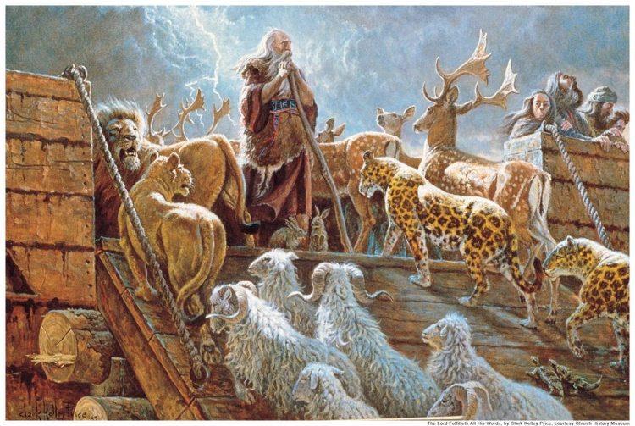

How many times have we heard people say words to the effect, “If you tell me that there is only one way to Heaven, then you are condemning me (or “my family,” “others,” etc.).”? Is this a valid charge?
Friends, when one takes a stand for the truth, he will be condemning those who are not following the truth. Please read Hebrews 11:7. “By faith Noah, being warned of God of things not seen as yet, moved with fear, prepared an ark to the saving of his house; by which he condemned the world, and became heir of the righteousness which is by faith.” When Noah built the ark, following God’s plan to the letter (Genesis 6:22), the Bible says he condemned the world. How did Noah do this? He condemned the world in three ways:
1) He condemned the world by living by faith (Hebrews 11:7). God told Noah what to do and he did it without question (Romans 10:17; Genesis 6:22). His family followed his lead (1 Peter 3:20). The rest of the world refused to listen to God through the preaching of Noah, (2 Peter 2:5) and drowned in the Flood. Notice that this verse begins and ends stating that Noah lived “by faith” (Hebrews 11:7).
2) He condemned the world by heeding the warnings of God (Genesis 6:13). Again, when the people heard Noah’s preaching, they refused to follow God’s will and get into the ark. When Noah was warned of “things not seen as yet,” he heeded the warning. In like manner, we are warned by God of an eternity in Hell for our disbelief and disobedience. Are we heeding the warning of the Lord who has said He will come “in flaming fire taking vengeance on them that know not God and that obey not the gospel of our Lord Jesus Christ” (2 Thessalonians 1:6-9)?
3) He condemned the world by preparing for the coming flood. Noah’s preparation of the ark showed that he not only believed in God, but believed God. Those who have faith in God will do what He says to do (Romans 10:16). Noah prepared for the Flood and condemned a world of fools (Matthew 25:1-13). In Matthew 25:1-13, we see where those prepared were rewarded and those who refused to prepare were condemned.
Did Noah talk down or act rude to the people? Of course, not! Nevertheless, he condemned the world at that time because he followed God and had the backbone to stand for his convictions and preach God’s word to others. He did God’s will regardless of the consequences to himself or his family. There are too few people like this today. Let us stand behind God’s will and have the backbone that was characteristic of Noah! Have we complained that someone was “condemning” us? Perhaps it was because they were doing God’s will, and we were not! Let us repent while we have time (Luke 13:3; 2 Corinthians 6:2).

