Churches Filled With Irrelevant Salt
Terry W. Benton / Auburn Beacon

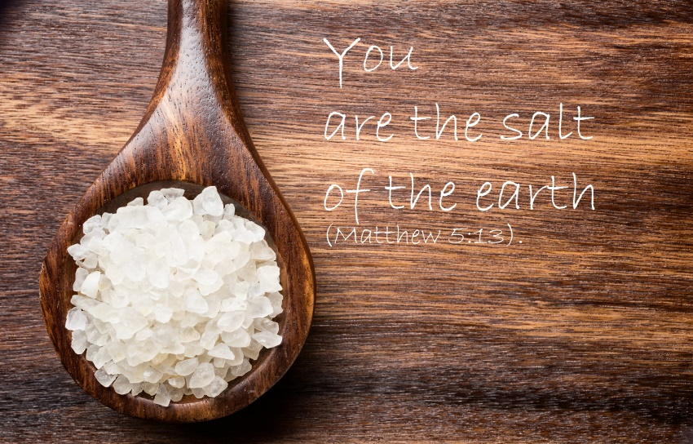

Jesus said His disciples would be the salt of the earth unless the salt loses its savor (Matthew 5:13f). When we consider the number of churches in this country and then compare that to the moral and spiritual decline in our country, the necessary inference is that “Christians” have made themselves irrelevant.
This means that the majority of those who profess to follow Christ on Sundays, look, act, and talk just like the world on the rest of their time. The problem in America is that there is not enough visual and vocal voice for the gospel. People should know by our talk, dress, behavior and spiritual priorities, that we stand for what is right and holy and moral. We influence people to think of God and His will. There are enough church attenders to make a huge difference, but what we find in too many places is shallow faith with little to no conviction. Many churches have become nothing more than a social club that gets immoral people to just “feel good about themselves” with little to no emphasis on repentance and change so that we can influence others to also change with us.
This is what happened in Israel before their fall. They tuned out “truth-teachers” like Jeremiah, and hired men to tell them “peace, peace” when there was no peace between them and God (Jeremiah 6:10-15). The people felt good about themselves as they became salt that was fit for nothing but to be cast out and trodden under foot of men.
We must all ask ourselves some serious questions. Have we become irrelevant Christians? What can we change in order to be a spiritual difference maker? These are things I’m sure God wants us to continually ask ourselves. Churches can make a moral difference if each one will care enough to emphasize a difference that must begin inside each individual Christian. Let true peace with God begin in me so that I can point the way for others to also have peace with God. Friendship with the world is enmity with God (James 4:4). Peace with God must be top priority.

