Churches And Their Buildings
Bill Hall / Hazelwood Messenger

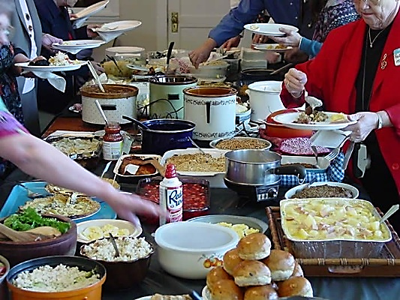

Burton Coffman, in his commentary on Romans 16:5 makes the following comment concerning the church’s meeting in the house of Aquila and Priscilla, “In view of this historical fact, and the inspired evidence of it before our eyes, one may only marvel at the divisions among brethren over the question of whether or not food may be served in the “church house!” From the facts, as evidenced in the example of Priscilla and Aquila, it can safely be inferred that anything a Christian might do in his house could, under the proper circumstances, be done in a religious meeting house, the home in fact having been the original meeting house of the apostolic church, pg. 513.”
We suspect that our readers are surprised at such a statement. Do we really believe that anything that can be done in one’s home can be done “appropriately” in the meeting house owned by the church?
But wait! This is not the real issue involved in the “divisions” mentioned above. According to these brethren, not only can churches serve meals in their meeting houses, but they can build the facilities into their meeting houses that are needed for serving meals – and this from money contributed for the Lord’s work.
Could we not carry brother Coffman’s reasoning one step further, then, to say that anything a Christian might build into this house can, under the proper circumstances, be built into religious meeting houses? Bedrooms? Swimming pools? Recreation rooms? We know a family who has built a beauty shop into their house. A beauty shop in the church building? And the lady gives perms and sets hair as a business in her home. Could she do this “under the proper circumstances” in the church building? In fact, it is at least possible that Aquila and Priscilla had a “tent-making” area in their house, for that was their occupation. A tent factory built into a meeting house with money from the treasury?
Besides, we have known churches that met in YMCA’s, union halls, prisons and courthouses. Does it follow that anything a Christian might do in one of these facilities, “could, under the proper circumstances,” be done in a religious meeting house?
The truth is, a church owned meeting house is authorized as an AID to worship and Bible teaching, which are God-ordained church activities. Whatever is needful to facilitate these God-ordained activities should therefore be built into meeting houses. In keeping with this, if God ordains social activities, recreation and secular education as local church activities, church should build facilities and provide food, balls, bats, racquets, school teachers, books etc… that will serve as AIDS to these activities. But, if they are not God-ordained church activities, churches have no authority to build into their building’s facilities for such. And to do that for which there is no Bible authority is sin: 2 John 9, 2 Timothy 3:16-17, 1 John 3:4. This is the real issue in this controversy.

