Church Attendance Is Essential; Part #1
Garland M. Robinson - Seek The Old Paths; Vol. 32, No. 7 - July, 2021

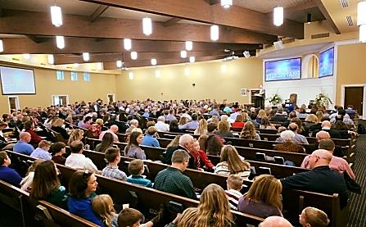
Church attendance is not a “take it or leave it” situation. It is unthinkable for one who has embraced the Lord’s Way (Acts 18:25), who has been washed in the blood of the Lamb (Revelation 7:14), who has been renewed in heart and soul (Acts 4:32), to forsake even one of the assemblies of the saints. The Bible is clear regarding the sin and the severity of forsaking the assemblies of the saints. “And let us consider one another to provoke unto love and to good works: Not forsaking the assembling of ourselves together, as the manner of some is; but exhorting one another: and so much the more, as ye see the day approaching. For if we sin wilfully after that we have received the knowledge of the truth, there remaineth no more sacrifice for sins” (Hebrews 10:24-26).
Far too often, members of the Lord’s house see church attendance as an unpleasant experience. It is often viewed like bad tasting medicine, something that is not enjoyed, but it’s necessary for one’s health. What a shame such individuals have so little faith! I’m convinced they do not see the severity of sin and the eternal destruction it brings.
To be able to worship the God of heaven, the Creator and Sustainer of all living (Acts 17:28), and to commune with brethren of “like precious faith” (2 Peter 1:1), is a blessing enjoyed by far too few who have “named the name of Christ.” The blessings and rewards of church attendance are many. If you’re not present in these assemblies it’s your loss.

CHURCH ATTENDANCE STRENGTHENS NOT ONLY THE INDIVIDUAL BUT ENTIRE FAMILIES AS WELL. One evidence of this is seen in the number of couples that have happy marriages. Statistics prove that families who worship together are far more likely to remain together. Rare are the occasions where such homes are broken and end in divorce. When families are constantly instructed in the “way of the Lord,” it becomes harder for them to rebel against that which is right. The prodigal son removed himself from family worship and influence and fell into the depths of sin and folly. Only after returning home did he once again enjoy the pleasure and company of those who truly loved him (Luke 15:11-24). Lois and Eunice brought Timothy up in the nurture and admonition of the Lord (2 Timothy 1:5; Ephesians 6:1-4). If you’re not present with your family, you’re not leading them in the way they should go (cf. Proverbs 22:6).

CHURCH ATTENDANCE PLACES YOU IN THE MIDST OF THE BEST PEOPLE IN THE WORLD. It is a place of safety and comfort. There’s no worry about someone seeking to take advantage of you. You don’t have to worry about turning your back for fear someone may steal from you. You have confidence your children will not be bombarded with foul language and obscene gestures. Such fills the TV, school and neighborhood. You don’t have to worry about “perverts” looking for a chance to molest you or your children. With all the crime, lust, greed, outrage, abomination, obscenity and lewdness in the world, why would families not seek to escape such and provide that which is wholesome, good, honorable, generous, beneficial and positive? All these good things and many more are found in the assemblies of the saints (Galatians 5:22-24). (Part #2 - next Sunday, Lord willing)

