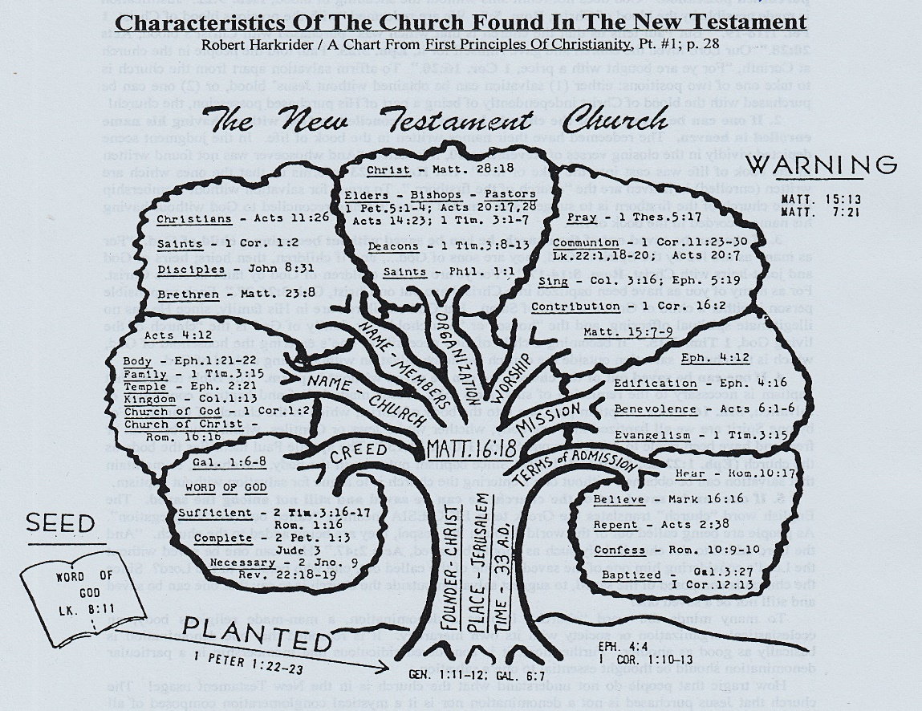

Sheet Sermon Sunday – A Great Chart About The Church Of Christ

About 75 years ago, a lot of sound gospel preachers used an “antiquated” version of today’s PowerPoint which was known as a Sheet Sermon (where they would take a common bed sheet and paint a chart about a Biblical principle) and then, preach their sermons from the bed sheet that they hung up for the audience to look at during their sermon. You can still find several of these sheet sermons pictured on-line, along with a host of great Bible charts like the one pictured here.
I found this chart a few decades ago in brother Harkrider’s class book mentioned in the caption on the chart. It is one of my favorite charts as it ably encapsulates our Lord’s teachings about the church we read about in the New Testament in one picture.
This morning’s 10:30 AM sermon will focus on several points made in this chart. As the lesson is being preached, it will help to keep this bulletin handy as the type is quite small on our PowerPoint screen in the auditorium (especially for those sitting the in back). This is a great chart to help us identify the Lord’s church and it begs to be shared with our neighbors & friends. (-kds)

