By Faith, The Walls Of Jericho…
Kenneth D. Sils

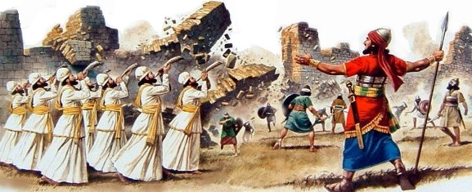

The walls of ancient Jericho “came a tumblin’ down!” It’s an amazing story from the Old Testament which serves as a “testament” to the faith of that 2nd generation Israelite as they all fled Egypt’s brutal slavery. Collectively, they were “full of faith”, ready to possess the land God promised them decades ago!
Here lies the secret to real “faithfulness”: they watched their parents die due to their rebellious challenge of God’s authority and they were bound and determined -- that wasn’t going to be them! I think they would’ve “swam the largest ocean” and “climbed the highest mountain” if God would have ordered them to “swim” or “climb”! Their faith in God was so strong that obedience to God’s most difficult or even eccentric command would not be questioned! They silently and reverently marched when they were commanded and they did that day after day, as long as Joshua commanded such. When Joshua changed the parameters on the 7th day, they loyally obeyed. They were faithful! Jesus is our General today. His orders are sure and steadfast, codified in the New Testament. By faith, we should march as loyal, reverent soldiers too!

