An Outward Sign Of An Inward Grace
Heath Rogers / Poudre Valley e-bulletin
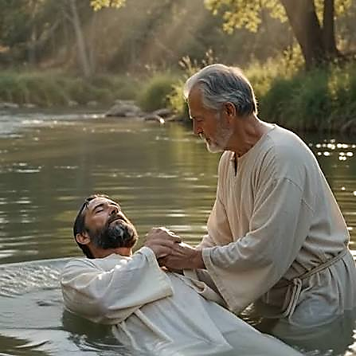
One thing that makes churches of Christ different from many denominational churches is our teaching and practice regarding the purpose of baptism. We believe water baptism (preceded by sincere belief in Jesus as the Son of God, repentance of our sins and confession of our faith) is essential for salvation. The official teachings of many denominations deny this fact, stating a person is saved the moment they believe and accept Jesus as their personal Savior.
These same groups practice water baptism, but not for salvation. They teach a Christian (a saved person) ought to be baptized because Jesus was baptized and He later commanded baptism. Many use water baptism as the means of becoming a member of their particular denomination. Some also say a Christian’s baptism is a means of showing outwardly what has already taken place in their heart. It is a display (not the means) of their salvation. It is: an outward sign of an inward grace.
Edward T. Hiscox, in The Baptist Church Directory, states that baptism, “represents in an outward symbol the inward work of the Spirit, and shows how, ‘according to his mercy, he saved us by the washing of regeneration, and renewing of the Holy Ghost,’ a work already performed upon the heart of the candidate, by an application of the cleansing blood of Christ” (p. 32).
Hiscox is wrong. This popular error can be corrected with an honest consideration of the conversion of the apostle Paul. Those who teach salvation by faith alone believe Saul of Tarsus (the apostle Paul) was saved on the road to Damascus. Having seen the Lord on the road, he believed and accepted Him as the Christ, and entered the city a saved man. This conclusion can’t be drawn from the facts of the account; it must be brought to the account.
When the Lord appeared to Saul on the road, He told him to, “arise and go into the city, and you will be told what you must do” (Acts 9:6). Blinded by the vision, Saul had to be helped into the city. He was three days without food or drink, praying. This shows his faith and repentance. He was convinced that Jesus was the Son of God and he was genuinely sorry for his opposition to God’s will. When Ananias arrived, he told Saul, “And now why are you waiting? Arise and be baptized, and wash away your sins, calling on the name of the Lord” (Acts 22:16). As the Lord had promised, Saul was told what he must do. He must arise and be baptized. For what reason? To wash away his sins. Contrary to the false doctrine of faith only salvation, Saul still had his sins. How can a person be saved from their sins while still having their sins?
Hiscox said baptism is, “an outward symbol of the inward work” of the Spirit already performed on the heart of the believer. However, the cleansing work of the Spirit had not yet been performed on Saul. He still had his sins when Ananias told him to, “stop waiting, arise, and be baptized.” Saul was not told to be baptized because his sins were washed away but to have his sins washed away. There is a difference between these two ideas - a difference which makes water baptism necessary for our salvation.
What were you told about baptism? Were you baptized because you believed you were already saved or in order to be saved? This is important. Eternity hinges on your answer. Please let us know if we can help you to be baptized to have your sins washed away.

