A Silent Sermon
author unknown

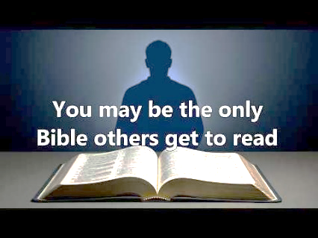

His name is Bill. He has wild hair, wears a t-shirt with holes in it, jeans and no shoes. This was literally his wardrobe for his entire four years of college. He is brilliant; kind of esoteric and very, very bright. He became a Christian while attending college.
Across the street from the campus is a well-dressed, very conservative church. They want to develop a ministry to the students, but are not sure how to go about it.
One day, Bill decides to go there. He walks in with no shoes, wearing jeans, his t-shirt and wild hair. The service has already started and so Bill starts down the aisle looking for a seat. The church is completely packed, and he can’t find a seat. By now, people are really looking a bit uncomfortable, but no one says anything. Bill gets closer and closer and closer to the pulpit, and when he realizes there are no seats, he just squats down right on the carpet. Although perfectly acceptable behavior at a college fellowship, trust me, this has never happened in this church before. By now the people are really uptight, and the tension in the air is thick.
About this time, the minister realizes that from way at the back of the church, a deacon is slowly making his way towards Bill. Now the deacon is in his eighties, has silver-gray hair and a three-piece suit. A godly man, very elegant… very dignified… very courtly. He walks with a cane, and as he starts walking towards the boy, everyone is saying to themselves that you can’t blame him for what he’s going to do. How can you expect a man of his age and of his background to understand some college kid on the floor?
It takes a long time for the man to reach the boy. The church is utterly silent except for the clicking of the man’s cane. All eyes are focused on him. You can’t even hear anyone breathing. The minister can’t even preach the sermon until the deacon does what he has to do.
And now they see this elderly man drop his cane on the floor. With great difficulty, he lowers himself and sits down next to Bill and worships with him so he won’t be alone. Everyone chokes up with emotion. When the minister gains control, he says, “What I’m about to preach, you will never remember. What you have just see, you will never forget.”
Be careful how you live. “You may be the only Bible some people will ever read.”

